Isaac Gluck

Jason McCoy

Eisha Rajbhandary

Anton Solak

Gellert Toth

PREDICT 480- Sec56

**Transformation Plan: Team Regal**

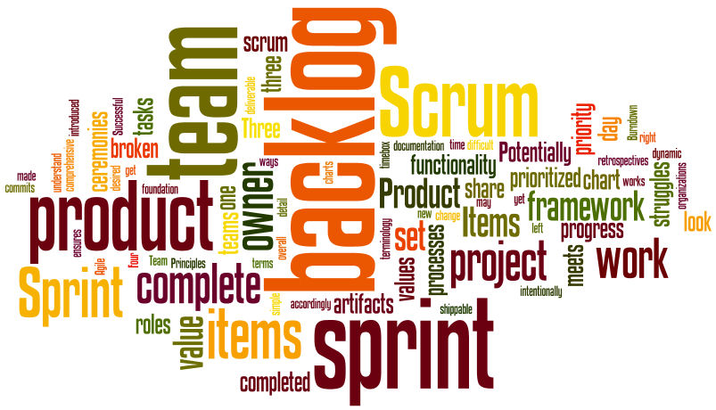

August 26, 2018

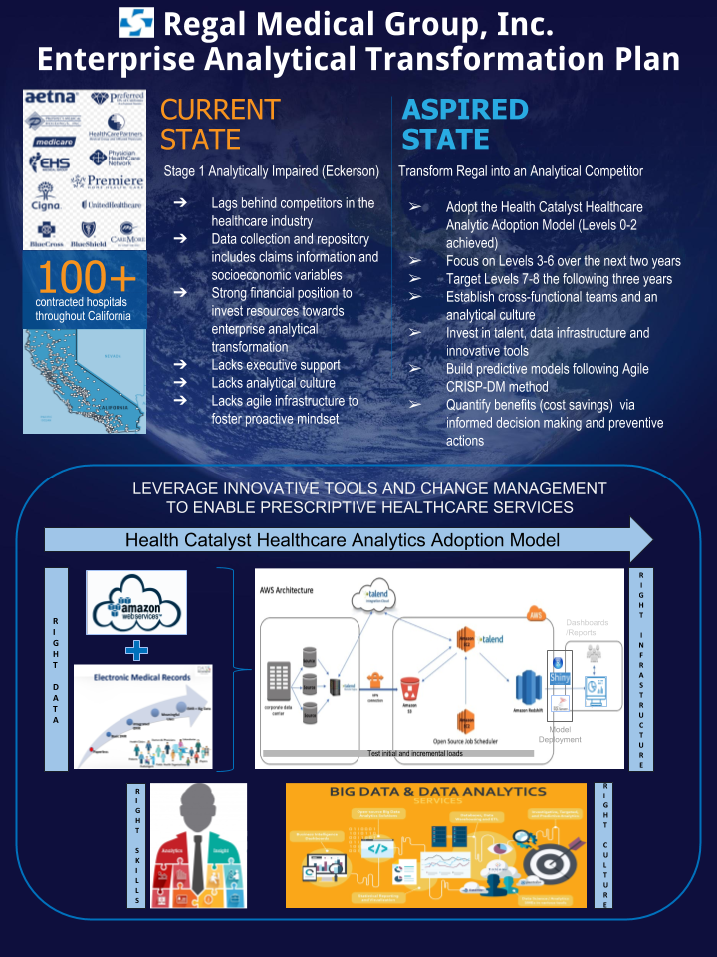

# Transformation Framework:

A cross functional team will be formed at Regal Medical Group with members from the Analytics, IT, Finance and Medical departments. The team will follow the Health Catalyst Healthcare Analytic Adoption Model1. The company is at Level 2 today although elements of higher levels already exist making it possible to quickly adopt and surpass these lower levels.

The next five years will be spent by the team to transform the organization and surpass all eight levels of the Healthcare Analytic Adoption Model. During the next two years, the team is expected complete transformation through Level 6. Levels 7 and 8 will take three additional years to achieve.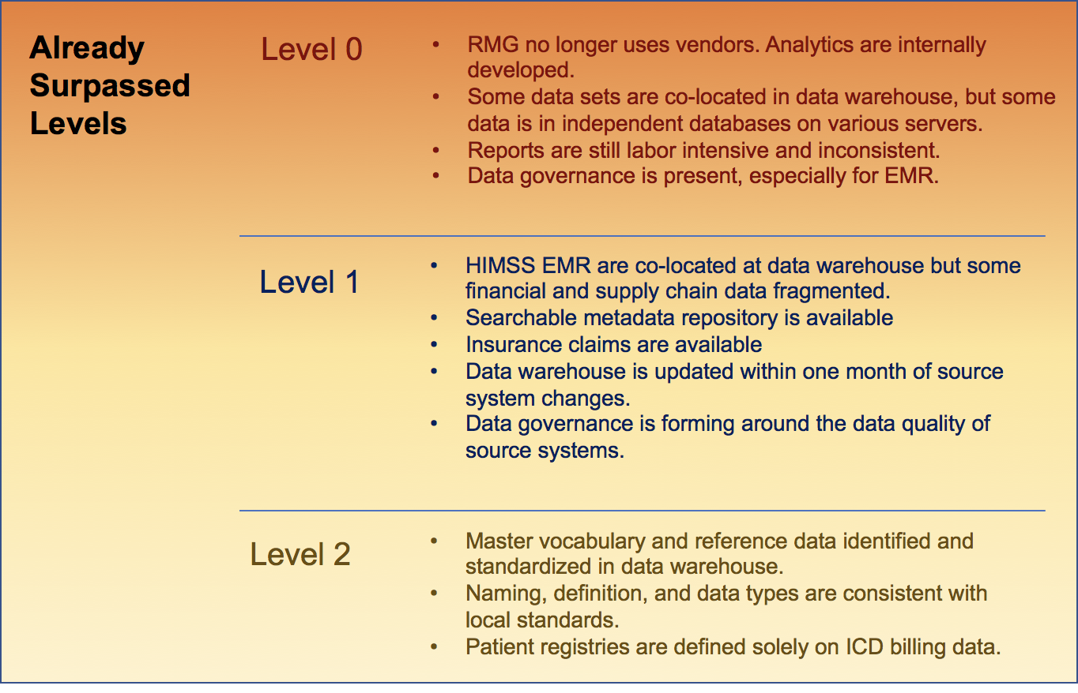

**Level 3 - Automated Internal Reporting:**

The team will focus on consistency and efficiency of internal reports. The focus of Level 3 analytics will be reports that will be used by management. KPIs needed for senior level decision making will be targeted.

**Level 4 - Automated External Reporting:**

RMG is required to file reports needed for accreditation and has regulatory requirements that must be fulfilled to governmental organizations such as the Center for Medicare Services, CHIP and other entities within the US government. At this stage, the team will focus on the standardization of vocabulary and data assets and will streamline the searchability of records. All data governance will be moved under a central authority at this stage.

**Level 5 - Waste and Care Variability Reduction:**

Standardization of clinical practice and the introduction of best practices will be the focus of Level 5. An improvement in health outcomes will benefit the financial side of RMG while improving patient satisfaction and care. At this stage, the analytics team will expand and recruitment for a new Real World Evidence department will take place where analysts will focus on population-based analytics. The overall goal of a RWE team will be quality improvement in patient care, reduction in morbidity and mortality while at RMG as well as cost reduction across various workflows within RMG institutions.

**Level 6 - Population Health Management and Suggestive Analytics:**

RMG will be transformed to a true Accountable Care Organization at this stage where analytics will lead the organization in maximizing the quality of patient care while making it economically feasible to do so within local populations in Southern California. Data will be collected from patients in an outpatient setting through devices and pharmacy transactions will also be integrated with medical and insurance data.

**Level 7 - Clinical Risk Intervention and Predictive Analytics:**

Reimbursement models will be generated to improve the financial performance of RMG. Note that our demonstration project already targeted this area since the model sought to understand the relationship between certain patient and practitioner factors and bed days which then evolved into a predictive tool for forecasting, risk stratification to support outreach and a signal for escalation.

**Level 8 - Personalized Medicine and Prescriptive Analytics:**

The final step in RMG’s analytic transformation will be the creation of analytical models that manage wellness and prevent disease or disease progression. Prescriptive analytics will offer real-time solutions at the point of care based on biometric, genomic and familial data.

# Analytics Gap and Strategy:

Currently, RMG is an analytically impaired organization with some localized analytical capabilities. While it possesses the data necessary to implement analytical programs and initiatives, it lacks the executive interest and analytical activity to be anything more than a Stage 1 company (as defined by Davenport and Harris2). In the intermediate-term, the goal is to transform RMG into what Davenport and Harris term an analytic competitor.

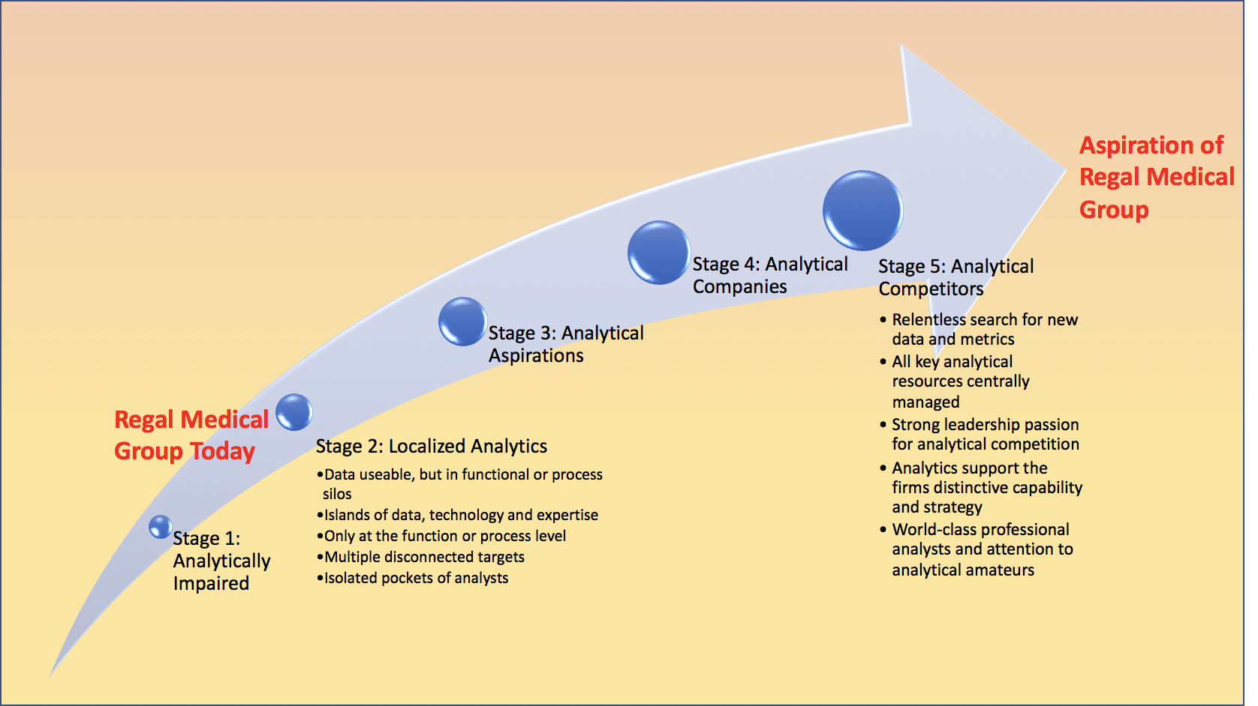

Fig 1: Analytical Maturity Model (Eckerson)

In order to move RMG along the Healthcare Analytic Adoption Model1 continuum and analytical maturity continuum3, the following strategies will be adopted:

**Level 3 - Automated Internal Reporting:**

*Method of Value Creation:*Internal reports on the operations of RMG will create consistency month over month while efficiently depicting the company’s performance. Data governance will allow RMG to begin treating data as an asset.

*Beneficiary of Transformation:* Middle and Senior Management will be able to make more informed decisions by reviewing KPIs on a regular basis.

*List of Changes:* Dashboards will be designed and data used in reports will be standardized. Behavioral change will also be needed as executives will have to regularly review KPIs and make corrections according to need. Since dashboards are a self-service tool, managers will need to refrain from requesting information from analysts who will spend more of their time on moving RMG along the Healthcare Analytic Adoption Model1 continuum.

**Level 4 - Automated External Reporting:**

*Method of Value Creation:*External reports will be created to reduce the cost and time associated with mandated reporting requirements while ensuring error free data transmission.

1. Regulatory requirements: Automated reporting to governmental agencies such as the Center for Medicare Services will enable RMG to efficiently comply with requirements so that financial penalties due to non-compliance are not levied against the company.
2. Accreditation requirements: The Joint Commission (formerly JCAHO) is necessary for healthcare organizations to continue operations. Reports must be regularly filed with the JC for review about quality metrics and other health related hospital performance data.
3. Payer requirements: Quality reports such as PQRS as well as Value Based Payment schemes require RMG to file reports with payers to get preferential reimbursement rates which impact the bottom line greatly.
4. Scientific database requirements: Organizations such as the National Organization for Myocardial Infarction, cancer registries, clinical trial organizations etc. require regular reporting.

*Beneficiary of Transformation:*  External reports are required for continuous operations of RMG. They also provide financial benefits therefore all employees gain from them. Shareholders also benefit since the financial performance of RMG drives equity valuation of the company.

*List of Changes:* Analysts will need to ensure that language used in external reports as well as structure of these reports adhere to industry standards. Further improvements in data governance and strategy will also need to happen.

**Level 5 - Clinical Effectiveness & Accountable Care:**

*Method of Value Creation:*Analytics will ensure the utilization of best practices in clinical care and patient management. The most effective healthcare providers enforce strict standards in clinical care to reduce error and financial burden on patients and the healthcare system while improving clinical outcomes. At this stage, the analytics team will start the harmonization of data from various departments at RMG.

*Beneficiary of Transformation:* The main beneficiary of Level 5 are patients both in terms of health outcomes and reduced cost.

*List of Changes:* Multidisciplinary teams will need to be organized with the mandate of continuous monitoring of quality of care, cost, safety, risk, etc.

**Level 6 - Population Health Management & Suggestive Analytics:**

*Method of Value Creation:*Organizations at Level 6 engage in practices that tie financial performance to clinical outcomes. Payment for services is no longer itemized but assessed as a bundle. Data will need to be integrated across the continuum of care where affiliated system physicians, hospitals, long-term care facilities etc. enter patient data into the same system enabling a single continuous view of a patient’s health journey.

*Beneficiary of Transformation:* Patients receive better care while the financial performance of RMG also improves significantly. New products and services will be created and offered based on analytics.

*List of Changes:* Integration of all system within all units and disciplines of RMG will be necessary.

**Level 7 - Clinical Risk Intervention & Predictive Analytics:**

*Method of Value Creation:*Risk sharing is across the enterprise. All healthcare professionals (nurses, doctors, social workers, anyone interacting with a patient) are accountable for the well-being of a patient independent of which part of the system the patient is navigating. Decision making in patient care will be greatly enhanced and new products and services may be introduced as a result of using clinical risk intervention and predictive analytics.

*Beneficiary of Transformation:*  Patients receive better care while the financial performance of RMG also improves significantly.

*List of Changes:* Collaboration will be necessary across the enterprise which is partly enabled by innovative IT technologies and analytical solutions. At this stage, predictive analytics is the mainstay of analytics within RMG. Data generation and collection may start outside of RMG system and facilities.

**Level 8 - Personalized Medicine & Prescriptive Analytics:**

*Method of Value Creation:*Analytics is now used for prevention as opposed to just treatment and may bridge mental and physical health issues.

*Beneficiary of Transformation:*  Patients receive better care while the financial performance of RMG also improves significantly.

*List of Changes:* The integration of biometric, familial and genomic data will be necessary. Machine learning and artificial intelligence will lead value creation from an analytics perspective. Many data elements will be available real-time.

# Pipeline of Demonstration Projects (Applications)

Demonstration projects will enable the team to showcase capabilities as they mature along the Healthcare Analytics Adoption Model continuum.

1. **Automated KPI Dashboard focusing on key areas that impact RMG’s bottom line** The project is expected to take six months and will serve as the demonstration platform for Level 3. Some of the areas of focus will be:

* Provide early warning system for ICU patient downturns based on monitoring of bedside medical devices
* Optimize Urgent Care/ER staffing levels based on predictive analysis of patient flows
* Reduce readmission rates by identifying and targeting preventable cases for intervention
* Increase patient wellness by creating and monitoring personalized recommendations regarding lifestyle and habits
* Provide diagnostic assistance via predictive model based on symptoms, demographics, patient history, etc.

1. **Automated filing with the Joint Commission to maintain accreditation**

The project is expected to take six months and will serve as a demonstration of Level 4 capabilities. While the Joint Commission requires inspection and reporting on a wide variety of items, the team will focus on specific items such as surgical site infections within 30 days of surgery, refill of soap dispensers, hand sanitizer use and output data from the Infection Control tool.

1. **Data harmonization within Pharmacy, EMR and Insurance Claims**

The project is expected to take a year, and will demonstrate Level 5 capabilities. Pharmacy transactions including rejection at checkout will be connected to all fields of Electronic Medical Records as well as insurance formulary data and insurance financial transactions (including rejections, reversals, etc.). Formulary data will contain restrictions regarding the use of drugs and/or procedures so that prescribing of therapy becomes more streamlined and patient satisfaction increases.

1. Level 6 capabilities will be demonstrated through further enhancing RMG’s **data governance**. The goal will be to integrate all units and providers within the RMG system and will require an additional six months following the completion of the Level 5 demonstration project. During this phase, the following issues will be addressed: 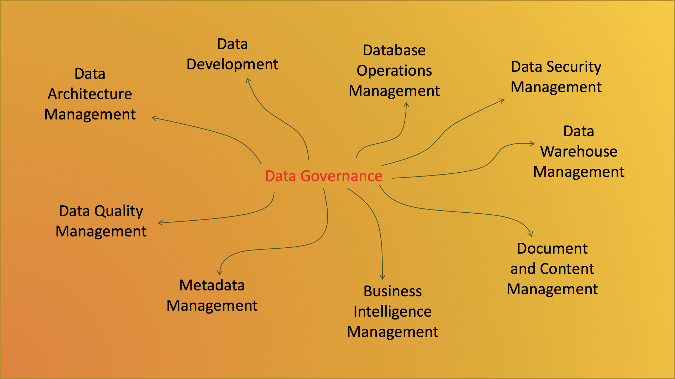

Fig 2: Data Governance key areas

1. A refinement of the team’s original demonstration project will be completed. The bed day reduction model will be turned into a predictive model targeting financial performance due to an increase/decrease in bed days. Machine learning will be used and various steps across the patient journey will be considered as independent variables. Models will use data elements developed during Level 6 data integration.
2. Personalized medicine using data collected from wearables and integrated with EMR, mental health and other data will be the goal of the final demonstration project. Data generated outside of RMG may also be integrated in the analysis.

# People and Technology Infrastructure Investments

**Team and governance needed for transformation:**

A cross-functional team will be assembled with representatives from various functions within RMG. A core team of five people and an executive sponsor will start the Enterprise Analytical Transformation Project and RMG’s journey through the Healthcare Analytic Adoption Model continuum.

Fig 3: CRISP-DM and Agile Scrum Framework4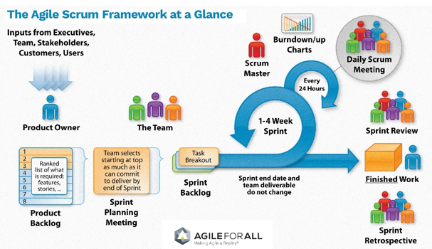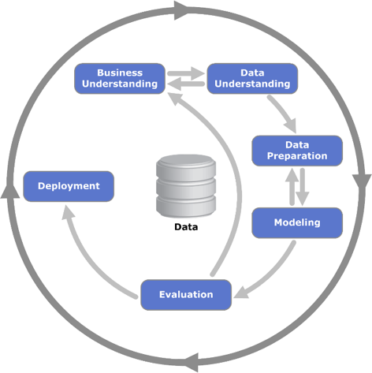

Several development teams will be formed with Subject Matter Experts (SMEs) outside of the core team for each individual level. Each development team will follow SCRUM principles.

A steering committee consisting of team leads and C-level executives will be formed to enable constant communication and monitoring of the progress. As Eckerson states, having the right corporate culture is one of the keys to analytical success.3 To enable change and manage goals and expectations of the project, RMG needs to focus on its culture which currently does not treat data as an asset. RMG will follow the ADKAR change management model to help foster a culture values analytics.5 Change Management is a series of proactive, coordinated and dependent activities designed to move people along the curve towards adoption and commitment while minimizing disruption to the business. The ADKAR model is useful in effectively managing change on an individual and organizational level by focusing on the following five goals:

* Awareness: RMG executive sponsors will hold departmental as well as company-wide sessions to help associates understand the importance of the transformational project and recognize the value add. Management will play the role of evangelists and communicate the intrinsic value of analytics to their teams and associates and the need for investing resources in the EATP.
* Desire: RMG will show direct benefits to various business units and associates through the demonstration projects in terms of gain in operational efficiency, informed decision making and increased profit sharing.
* Knowledge: A long term roadmap of the project with timelines and milestones will be distributed frequently. RMG will create Power User Groups who will act as Change Champions on behalf of the organization. Power Users will consist of members from across the organization who either perform critical business functions or are already heavy users of data and analytics. These Power User groups will focus on the different levels and help the Development Teams prioritize the Product Backlog Items. They will also perform End-to-End and User Acceptance Testing after each Sprint. Power Users will then disseminate learnings to their respective areas and move RMG along the ADKAR curve towards adoption and commitment.

Fig 4: ADKAR Change Management Model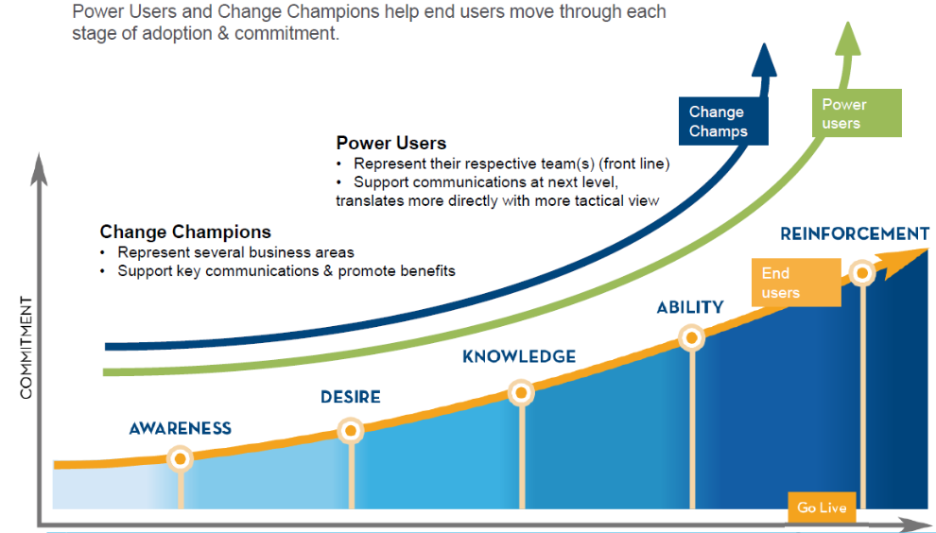

To provide continuous support to end users and have an open forum for communication and feedback between the EATP teams, Power Users and End Users, the following steps will be taken:

|  |  |  |  |
| --- | --- | --- | --- |
| **Area** | **Focus** | **Value** | **Sample Activities** |
| **Communication, Engagement, and Readiness (internal)** | * Effective ways to inspire, inform, and reduce anxiety to change  * Ongoing alignment of Leadership on decisions & impacts around structure, processes, and talent  * Assessing engagement, commitment & readiness targets | Clarifies the business model of the future; ensures an active dialogue to channel concerns; identifies where expectations are not met, and uncovers new challenges to address in new change interventions | *Change Champion Network  *Monthly Roadshows & System Demos  *Change Summaries / Dept. *Discuss. Guides  *Videos, Articles & Web updates  *Lunch & Learns  *Change team participation in all Sprints  *Steering Committee updates  *Adoption/Readiness surveys |
| **Training (internal)** | * Creating knowledge, skills, ability and attitudes to work effectively with new processes and systems | Enables employees to be productive and minimize performance dips at go live and beyond. | * E-learning courses  * Instructor Led sessions  * Job aides |
| **External Partner Engagement & Training** | * Proactively managing Partner expectations through Sales team  * Exposing key partners in early demonstrations, testing, and change information | Reduces anxiety; allows time to answer questions; leverages Sales’ relationship with partners; helps prepare answers to FAQs; uncover communication/training gaps | * Partner Readiness Group  * Monthly updates for Top 50 accounts  * Dashboards  * Press Releases & market facing articles  * Webinars, E-learning, job aides |
| **Power Users and User Acceptance Testing** | * A representative group of end users to groom as the “go to” SMEs communication, process mapping, testing, and training | Spreads accountability; uncovers processes that will start, stop, continue in each dept.; provides input for training & communication; provides documentation of new/ interdepartmental process changes; helps Managers/HR with role, staffing & skill needs. | *Power User Monthly Meetings  *Power User Early User Testing  * Process Mapping exercises  * Power User Portal site  * Power User Reports  *Facilitated Process Redesign sessions  * User Acceptance Testing (UAT) |
| **Post Deployment Support** | A sustaining network and infrastructure to continue to support associates and agents with issues and resolutions post go live | Instills more confidence in agents by having a dedicated resource to raise issues and seek ongoing help with performance issues | * Post Deployment Planning  * Cut over plans & state roll out communication  * Risk Mitigation communication |

Table 1: Focus Areas for continued adoption and commitment

**Sustaining Behavior Change - Ability and Reinforcement:**

* Ability: RMG will utilize the knowledge base of the Power Users to document and create workflows for current processes as well as adapt them to the future state. This will assist in transfer of knowledge to end users and in their training to ensure the right skill sets are being developed as RMG transforms.
* Reinforcement: RMG recognizes that change is not easy and that it is necessary to have frequent checkpoints with different user groups as well as have an open forum to discuss potential issues or setbacks. Coaching and training materials will be available for different business functions and regular information sessions will be held focusing on areas ranging from change management to hands on training on the new data and tools. The areas of focus mentioned in Table 5 above will also assist in ensuring the organization continues to move along the ADKAR curve towards adoption and commitment.

RMG, recognizing the large scale and scope of the EATP and its impact on the associates, will continue to invest resources in ensuring the right support system is in place to create a lasting cultural shift towards the adoption of analytics. In order to achieve a sustained cultural and behavioural change in the organization, RMG will use the system described in “Achieving Lasting Behavior Change”.

* Target Simple but Vital Behaviors: The three constructs associated with motivation and skills will be targeted, as described by Dr. Clare.

Table 2: Targeting Vital Behaviors 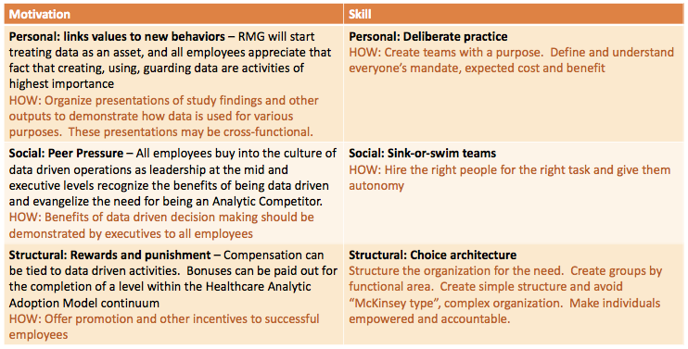

* Appeal to Heart and Mind but Mostly Heart: The book “Switch: How to Change Things When Change is Hard” lists several key items needed for successfully altering behaviors in a positive way. All of the items should be used during a successful transformation process that requires sustained behavior change within the organization. These items are valid across all individuals and tasks that are affected by change:
  + Identify successes and re-use them when appropriate.
  + Simple behaviors must be the focus of change
  + Identify and clearly articulate a goal
  + Create an empathetic workforce
  + Change behaviors in manageable increments
  + Create an identity that organizational change is strongly connected to
  + Create an environment that is conducive to change
  + Usher people along a path toward organizational change.
* Change the Environment to Change People: The ABC technique will be used when appealing to the heart. A represents activating an event, B is a series of beliefs that are activated by the event and C is the behavioral reaction to B. People can be “nudged” to a data driven culture by creating an environment where data is a focal point of activities within RMG. As an example, Memorial Sloan-Kettering Cancer Center made it mandatory to check for name and birthdate even within the same interaction within a hospital which avoids clinical and administrative mistakes in the hospital system. Several of these ABC techniques can be developed and the team will need to identify activating events across RMG.
* People change people so look to networks: Peer groups will need to be established when getting trained on the use of new systems. Power User Groups can be leveraged to help connect to end users. Group spirit may also be enhanced by celebrating successes. The establishment of a mentorship program may also be beneficial.
* Experiment: Since the teams will be using Agile PM approaches (SCRUM and CRISP-DM) at every step during the transformation process, experimentation will be a natural phenomena as team members will have to reiterate when problem solving.

**Big Data Analytics Ecosystem - *Data Management Process and Technology Architecture*:**

Currently, the culture at RMG does not treat data as an asset. Recognizing this gap, RMG executives together with the EATP teams (core team, development teams, SMEs and Steering Committee) will develop an enterprise data strategy. The overarching goal of the data strategy is to collect good quality data and deliver it to the right people at the right time to enable informed decision making through innovative and agile tools. This will also allow associates to converge around common goals and generate collaboration.

RMG recognizes that an integrated view of its corporate data is critical to its growth and analytical strategy. RMG already collects a plethora of data ranging from insurance claims to demographic and socioeconomic data but is looking to leverage external data sources, specifically Electronic Medical Records (EMRs), to augment its data. A traditional top down business intelligence solution such as an enterprise data warehouse simply will not be able to store the large volume of data, model and deliver results in a timely manner to achieve the levels of the Healthcare Analytics Adoption Model. Thus, realizing the importance of flexibility in managing big data, RMG will invest in procuring Amazon Web Services (AWS). AWS EC2 will be used for data exploration and modeling while Redshift will be used to store the data. In the big data playing field, change is constant and with it, RMG has to be able to adapt its data warehouse. The velocity and variety of data being collected is ever increasing at much more granular levels to enable companies to understand their customers better. Leveraging AWS to tackle the data flood allows data scientists to have access to a free-standing, high performance sandbox that will let them explore the data, determine its quality and importance prior to modeling and loading the data into the warehouse. RStudio, R Shiny and SQL will be used for various analytical tasks and training will be available for all skill levels. Business analysts, on the other hand, will have access to in-memory sandboxes and modern visualization tools to explore data and gain insights. Thus, RMG is investing in creating an analytical ecosystem that leverages both top-down reporting and bottom-up ad hoc exploration to create a holistic view while integrating power users and business users into the analytical environment.

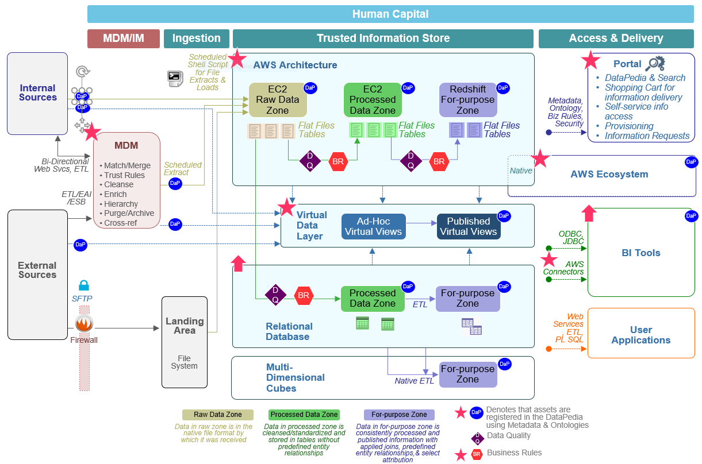

Fig 5: Regal Enterprise Analytical Transformation Project Architecture

# Top Three Risks and Mitigation Strategies

**Culture**

Regal currently lacks an analytical culture and is resistant to implementing analytics into the business model. Currently, the financial department is responsible for generating reports for executives and other departments. They also maintain the database warehouse and grant access to others as they see fit. As it currently stands, very few employees outside of the financial department have direct access to the data warehouse. Thus, it is difficult for outside departments to run their own analytics and must navigate through the finance department to merely attain the necessary data. This has made it incredibly difficult to implement an analytical culture within departments because simply accessing data is quite difficult. Additionally, the majority of executives lack an interest in implementing analytics within their own teams and departments which also makes it incredibly difficult to engage in a cultural shift without executive support and influence.

To become an analytical competitor, it is crucial for Regal to adopt an analytical culture. While incredibly difficult to implement, it is possible given the necessary executive support. A high-level executive with significant influence can become a catalyst for transitioning to an analytical culture. Currently, there exists a high-level executive in an operational role with a large team and significant influence who possesses the ability to drive this change. The executive understands the significance of analytics and believes it is crucial for an organization to infuse analytics into the business model in order to innovate and maintain financial success. This executive has the ability to drive the change and convince the other high-level executives that embracing analytics in necessary and optimal for the future success of the organization.

**Talent Risk**

There is a significant talent gap within the organization in relation to analytical capabilities. Regal lacks a core analytics team and there are various analysts scattered throughout the organization within varying departments. There is a group of business analysts within the finance department. However, they simply generate reports for executives and other departments. The first two data scientists within the organization were hired by the previously mentioned high-level executive. These two data scientists, however, have since left the organization for varying reasons that included the lack of an analytical culture and personal matters. This was essentially an experiment to determine if high-level analytics would survive within the organization and for a time it did but ultimately failed mostly due to personal matters. Thus, it is indeed possible for advanced analytics to be molded within RMG’s business model. It is crucial for Regal to develop a core analytics team that is comprised of data scientists, analysts and a Chief Data Officer (CDO) or Chief Analytics Officer (CAO).

Once again, it is up to a high-level executive to fill the talent gap and develop a core analytics team. The high-level executive previously mentioned possesses the influence to convince the CEO that it is crucial to develop a core analytics team. Following the executive approval, it will become necessary to hire the right people to fill the talent gap. These people will consist of data scientists, analysts with a strong statistics background and a CDO or CAO that not only understands the value of analytics but also has a firm grasp on the complex healthcare system.

**Data Management and Access**

Data management must be addressed given its lack of sophistication in its present state. Currently, there exists two database administrators (DBA) within the financial department that runs and maintains the data warehouse. As a result, these two DBAs possess the power to grant or restrict access to employees. As it stands, only a handful of employees outside of the finance department have access to the data warehouse. This makes it incredibly difficult for other departments to run analytical reports as oftentimes they must wait for approval to receive the necessary data they are seeking and wait until the specific team within the finance department gathers the data for them. This team often has a lengthy queue of tickets from RMG employees requesting either reports or data, which means that these departments wait several days to several weeks to receive the report or data they requested. This issue can be solved by simply granting read abilities to the data warehouse to other departments. This will allow departments to attain data when they see fit and in a more timely and efficient manner.

Additionally, the servers within the organization are often quite slow and can take a significant amount of time to gather data. It can take several minutes to several hours to run queries. There are several applications critical to the organization’s operations that employees utilize on a daily basis that run through the servers on the backend. These applications are often quite sluggish given the slow servers. A significant improvement would be to transition to a cloud-based platform such as Amazon Web Services (AWS) which is part of the overall EATP for RMG. This would eliminate the hindrance posed by slow servers and create a much more fluid data ecosystem.

# Revisit Initial Demonstration Project

Team Regal’s initial demonstration project focused on the business problem of costly bed days associated with high risk patients. The goal of the project was to establish a predictive model that resulted in measurable benefits i.e. reduction in bed-days via identification of high-risk individuals and preventative actions to get buy in from executives and other key stakeholders to invest in the EATP. RMG will re-visit the initial demonstration project as part of Level 7 of the Healthcare Analytics Adoption Model. One of the main issues at RMG today is that its current IT infrastructure is not agile enough to support the big data necessary for machine learning and prescriptive analytics. Thus, after successfully implementing Levels 3-6 of the Healthcare Analytics Adoption Model, RMG will have a robust AWS platform and analytical tools such as R Studio and SQL available to its data scientists allowing them to build complex models. As stated in the Project Pipelines section above, a refinement of the team’s original demonstration project will be undertaken at Level 7. The bed day reduction model will be turned into a predictive model targeting financial performance due to an increase/decrease in bed days. Models will use data elements developed during Level 6 data integration. Machine learning will be used and various steps across the patient journey will be considered as independent variables to prescribe preventive measures to patients and provide proactive care establishing RMG as a customer centric healthcare leader in the industry.

# Personal Philosophy of Analytical Leadership

The challenges of successfully enacting an analytic transformation should not be understated. While there will be no shortage of technical issues along the way, there will also be numerous challenges that are less well-defined and have no clear solutions. The analytics team as well as the broader organization will likely face periods of uncertainty and distress due to the magnitude of some of the changes that will occur. It will be important that all parties involved share a common vision and that motives and expectations remain aligned. For these reasons, capable analytical leadership is critical for the transformation plan to be realized.

We believe a successful analytical leader will model qualities of both an adaptive and a transformational leader. Though there will be numerous technical problems to be resolved, adaptive challenges – ill-defined issues with solutions that are beyond the sole capacity of the leader – will be just as crucial to overcome. This individual will have to embrace the characteristics of a successful adaptive leader:

* Find perspective amid challenging situations
* Differentiate between technical and adaptive problems and address them appropriately
* Help others manage their change-induced stress
* Encourage others not to avoid the difficult but necessary work
* Provide overall direction but delegate problem-solving to the extent possible
* Remain open to ideas from all group members

At the same time, transformational leadership is required almost by definition given the nature of the long-term organizational goals. This individual’s leadership cannot be strictly transactional, relying on contingent rewards to generate effort. Rather, the leader should articulate a vision and motivate followers to work collectively towards that vision by acting as a strong role model and building trust. Specifically, this individual should evince behaviors that are representative of a strong transformational leader:

* Possess the charisma and competence necessary to engender the trust and respect of followers
* Convey high expectations and encourage the confidence and motivation in others needed to reach them
* Provoke creativity in others by encouraging them to think and problem-solve independently and innovatively
* Be supportive of followers, considering their individual needs and coaching them to help reach their maximum potential

A successful analytical leader tackles management-facing responsibilities as well. This individual will play a critical role in understanding business goals and translating these into a plan of action (the first and most crucial step in the CRISP-DM process). To do so, the leader must maintain open channels of communication with senior management, business leads and other relevant stakeholders/customers. Further, the leader should convey the overall vision for analytic transformation to management as well as an ambitious but pragmatic plan for achieving it. The leader must not only secure buy-in from the C-suite but encourage them to be active evangelists and get the organization to believe in the intrinsic value of analytics and converge towards achieving the transformation goals.

To fill this role, an individual need not be a technical expert but should nonetheless have a thorough understanding of technical issues. Ideally, they should have experience leading a technical team through some type of transformational challenge. They should be charismatic, confident, determined, hard-working, and empathetic. In summary, their leadership philosophy should broadly read: “Leading and managing are not the same thing. A successful analytical transformation requires a leader who will gain the trust and respect of followers and inspire them to work together towards well-articulated goals, not prescribe actions or solve problems on their behalf. The inevitable technical and adaptive challenges can only be overcome by a committed and passionate team of people all working at their highest potential and the leader’s primary responsibility is to develop just such a team.”

Sources:

1. Health Catalyst Healthcare Analytics Adoption Model <<https://www.healthcatalyst.com/healthcare-analytics-adoption-model/>>
2. Davenport, T and Harris, J (2007). Competing on Analytics. Harvard Business School Publishing Corporation
3. Eckerson, W. (2012). Secrets of Analytical Leaders. Technics Publications.
4. CRISP-DM Methodology <<https://en.wikipedia.org/wiki/Cross_Industry_Standard_Process_for_Data_Mining>>
5. ADKAR Change Management Model <<https://www.prosci.com/adkar/adkar-model>>
6. Kraemer, H. M. (2011 ). *From Values to Action: The Four Principles of Values-Based Leadership.* John Wiley & Sons.
7. Rath, T., & Conchie, B. (2008 ). Strengths Based Leadership: Great Leaders, Teams, and Why People Follow. Simon and Schuster.